 | DATA SHEET  Model: |  | Client: xxx
 |  |  | Datasheet No.: xxxxxx-xxx-x-xx
 |  |  | Date: xx.xx.xx
 |  |  | Tag No.: xxx
 |  |  | Quantity: xxx
 |  | Fluid Data:
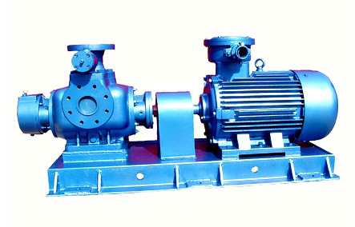 |  | xxx |  | Fluid Name
 |  | xxx |  | Temp. (°C)
 |  | xxx |  | Density (Kg/m³)
 |  | xxx |  | Viscosity (cP)
 |  | Pump Data:
 |  | TIANJIN HUAMAN / ASK |  | Manufacturer
 |  | Twin Screw Pump |  | Type
 |  | Horizontal |  | Pump Configuration
 |  | xxx |  | Design Temp. (°C)
 |  | xxx |  | Design Pressure (barg)
 |  | Performance Data
 |  | xxx |  | Rated Flow Rate (m³/h)
 |  | xxx |  | Diff. Press. (Rated) (bar)
 |  | xxx |  | Diff. Head @ P.T. (m)
 |  | xxx |  | Max Back Press. (bar)
 |  | xxx |  | Pitch Angle (°)
 |  | xxx |  | Rated Power (kW)
 |  | Materials:
 |  | W72 |  | Material Code
 |  | ZG35 |  | Casing
 |  | OCr17Ni4Cu4Nb |  | Screws
 |  | OCr17Ni4Cu4Nb |  | Shaft
 |  |  |  | Shaft Seal:
 |  | xxx |  | Seal Code
 |  | xxx |  | Type:
 |  |  |  | Heating:
 |  | xxx |  | Type Code
 |  | xxx |  | Method
 |  | xxx |  | Location
 |  | Motor Data:
 |  | Electric, Induction |  | Type
 |  | WEG / NANYANG |  | Manufacturer
 |  | xxx |  | Power (kW)
 |  | xxx |  | Speed (rpm)
 |  | xxx / 3 / 50 |  | Volt/Phase/Hertz
 |  | IP55 |  | Ingress Protection
 |  | xxx |  | Ex. Protection
 |  | F rise to B |  | Insulation Class
Outline Drawing |  | Dimensions (mm)
 |  | xxx |  | L₁
 |  | xxx |  | L₂
 |  | xxx |  | h₁
 |  | xxx |  | h₂
 |  | Nozzle Specification:
 |  | xx / PN10 / RF |  | N₁ (Suction)
 |  | xx / PN25 / RF |  | N₂ (Discharge)
 |  | EN 1092-1 |  | Flanges Standard
 |  | Notes:
Doc. No.: |  | ARYA SEPEHR KAYHAN

