 | DATA SHEET  Model: VS4/EGP |  | Client:
 |  |  | Datasheet No.: xxxxxx-xxx-x-A0
 |  |  | Date:
 |  |  | Tag No.:
 |  |  | Quantity:
Performance Curve |  | Fluid Data:
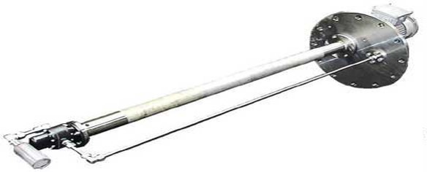 |  | xxx |  | Fluid Name
 |  | xxx |  | Temp. (°C)
 |  | xxx |  | Density (Kg/m³)
 |  | xxx |  | Viscosity (cP)
 |  | xxx |  | NPSHa (m)
 |  | Pump Data:
 |  | Vertical Gear Pump |  | Type
 |  | Anti-Friction, Bush Bearing |  | Bearing Type
 |  | Dry-Flexible |  | Coupling Type
 |  | Performance Data
 |  | xxx |  | Flow Rate (m³/h)
 |  | xxx |  | Differential Press. (bar)
 |  | xxx |  | Max. Disch. Press. (bar)
 |  | xxx |  | Max. Power (kW)
 |  | Materials:
 |  | xxx |  | Material Code
 |  | xxx |  | Casing
 |  | xxx |  | Gears
 |  | xxx |  | Shaft
 |  | xxx |  | Column
 |  | Shaft Seal:
 |  | xxx |  | Seal Type
 |  | xxx |  | API Plan
 |  | Motor Data:
 |  | Electric, Induction |  | Type
 |  | xxx |  | Manufacturer
 |  | xxx |  | Power (kW)
 |  | xxx |  | Speed (rpm)
 |  | xxx |  | Volt/Phase/Hertz
 |  | IP55 |  | Ingress Protection
 |  | xxx |  | Ex. Protection
 |  | F rise to B |  | Insulation Class
 |  | Weight (kg)
 |  | xxx |  | Pump
 |  | xxx |  | Motor
 |  | xxx |  | Other
 |  | xxx |  | Total
Outline Drawing |  | Dimensions (mm)
 |  | xxx |  | H
 |  | xxx |  | L.L.L (Low Liquid Level)
 |  | xxx |  | x (min)
 |  | F Installation
 |  | xxx |  | Flange Size (D) (inch)
 |  | xxx / 150# / FF |  | Std. / Rating / Facing
 |  | P Installation
 |  | xxx |  | L
 |  | xxx |  | W
 |  | Nozzle Specification:
 |  | xx / 150# / RF |  | N₂ (Discharge) (inch)
 |  | ANSI B16.5 |  | Flange Standard
 |  | Notes:
1-Dimensions are in mm
2-Drawings is not to scale, Not to be used for construction
Doc. No.: |  | ARYA SEPEHR KAYHAN

